OrcaXCare — Iteration 1
WDP301 | SE1816 — GROUP 4
POC Requirements · RDS · SDS
TruongNTCE180140 · ThangNDCE180608 · ThangDQCE182036 · TanhNTCE182341 · KhoaNNCE181612

I. Overview

1. Screen Flow
Iteration 1 delivers the system foundation: public portal, authentication, RBAC, master data (specialty, department, clinic room, doctor), patient profile, and role dashboards.
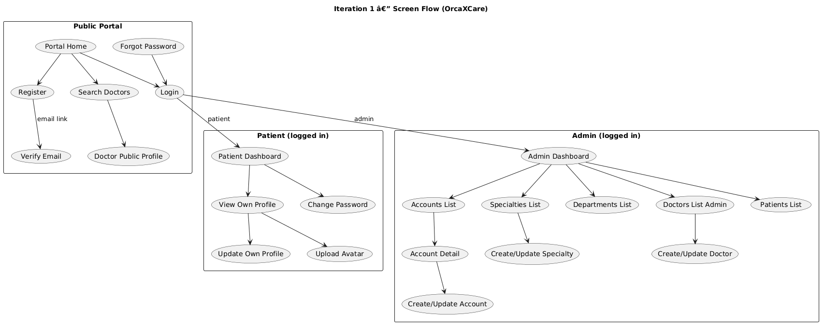
Figure 1 — Iteration 1 Screen Flow

2. Database Scheme
MongoDB Atlas collections for Iteration 1: users, patients, doctors, specialties, departments, clinic_rooms, email_verification_tokens, password_reset_tokens.
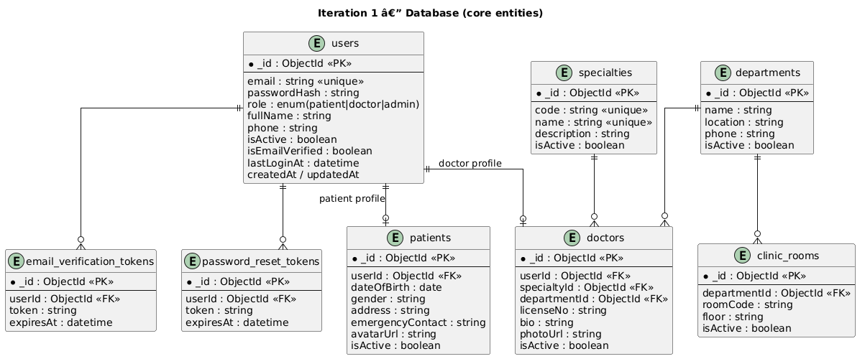
Figure 2 — Iteration 1 ERD (core entities)
Full system database diagram (reference for later iterations):
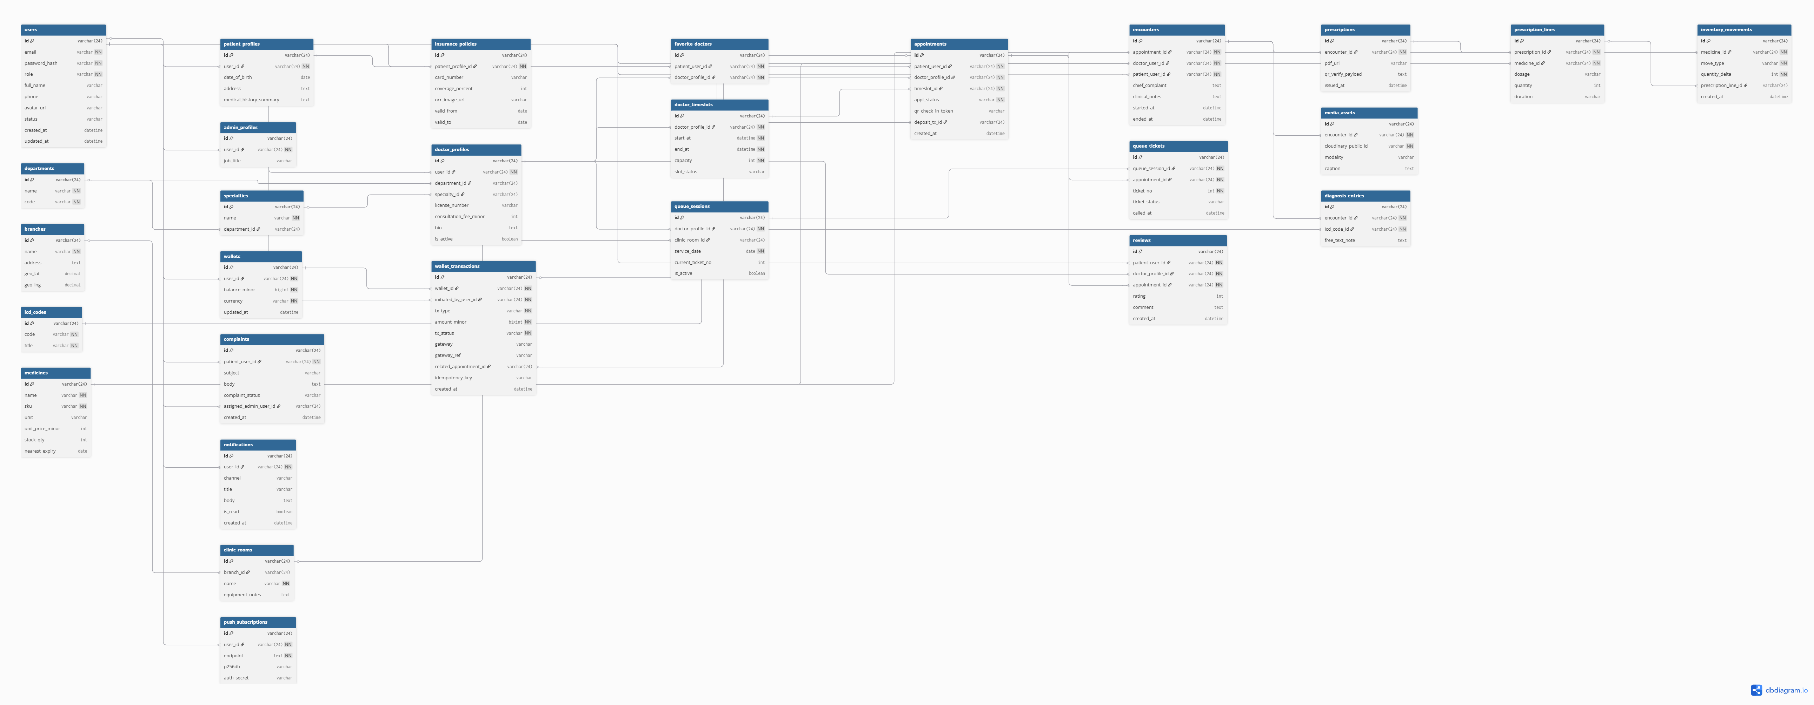
Figure 3 — OrcaXCare Full Database Diagram

3. Implementing Priorities
Priority Screens (prioritize from left to right):
#1 Portal Home, Register Account, Login, Patient Dashboard, Admin Dashboard, View Accounts List, View Specialties List
#2 Verify Email, Forgot Password, View Own Profile, Search Doctors, View Doctor Public Profile, View Doctors List (Admin), Create Specialty, View Departments List, Create Doctor
#3 Change Password, Update Own Profile, Upload Profile Avatar, Update Account, Create Department, Clinic Rooms, Update/Deactivate Doctor, Import/Export Doctors Excel, Patient List (Admin), remaining CRUD
Sprint outcome: Admin manages accounts, specialties, departments, and doctors. Patient registers, verifies email, logs in, updates profile, and searches doctors. Each role lands on the correct dashboard after login.

II. RDS — Requirements & Design Specification

1. Use Case Diagram
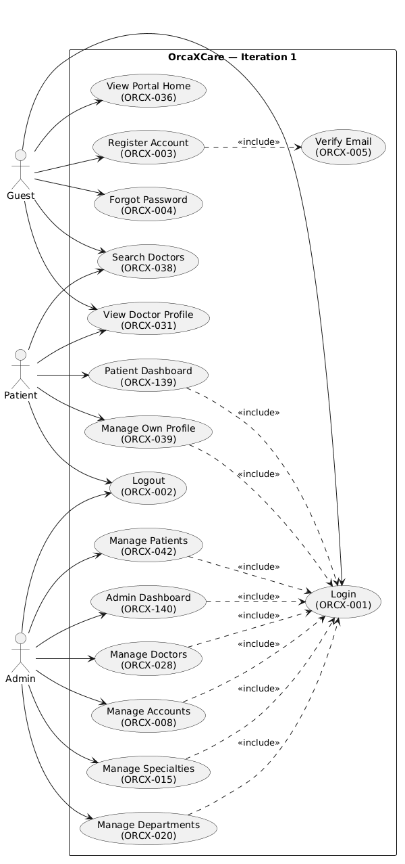
Figure 4 — Use Case Diagram (Iteration 1)

1.1 Actors
Actor | Description
Guest | Visitor without login; browse portal and register
Patient | Registered user; profile and doctor search
Admin | Manages accounts and master data

2. Screens Flow
See Figure 1. Navigation: shared header; Patient dashboard shortcuts; Admin left sidebar.

2.2 Screen Descriptions
# | Screen / Function | Feature | Screen/Function Description

2.3 Screen Authorization
Screen / Function | Guest | Patient | Admin
Portal Home / Search / Doctor Profile | X | X | X
Login / Register / Forgot / Verify | X
Patient Dashboard / Own Profile |  | X
Admin Dashboard / Accounts / Master data |  |  | X
Logout |  | X | X

2.4 Non-UI Functions
Function | Type | Description
Send verification email | Service | After patient register
Send password reset email | Service | Forgot password; link expires 30 min
JWT auth middleware | API | Protect routes by role
Password hashing | Service | bcrypt
Seed master data | Script | npm run seed — admin, specialties, departments

3. System High Level Design

3.1 ERD


3.2 Database Design
Collection | Key fields | Purpose
users | email, passwordHash, role, isEmailVerified, isActive | Authentication
patients | userId, demographics, avatarUrl | Patient profile
doctors | userId, specialtyId, departmentId, licenseNo | Doctor catalog
specialties | code, name, isActive | Specialty master
departments | name, location, phone | Department master
clinic_rooms | departmentId, roomCode, floor | Facility

3.3 Code Packages
client/src: pages, components, services/api, routes
server/src: routes, controllers, services, models, middlewares

4. Requirement Specifications (sample)

UC-ORCX-001 Login
Item | Description
Actors | Guest, Patient, Admin
Precondition | Account active; patient email verified
Main flow | Enter credentials → validate → JWT → redirect by role
Postcondition | Session established; lastLoginAt updated

UC-ORCX-003 Register + ORCX-005 Verify Email
Item | Description
Actors | Guest
Main flow | Register → email sent → user clicks link → account activated → can login
Postcondition | Patient user with isEmailVerified=true

III. SDS — Software Design Specification

1. Code Packages
Naming: PascalCase React pages; REST /api/auth, /api/admin; Mongoose models User, Doctor, Specialty.

2. Database Design
Indexes: users.email unique; doctors.specialtyId + isActive.

II. Code Designs

Feature: Login (ORCX-001)
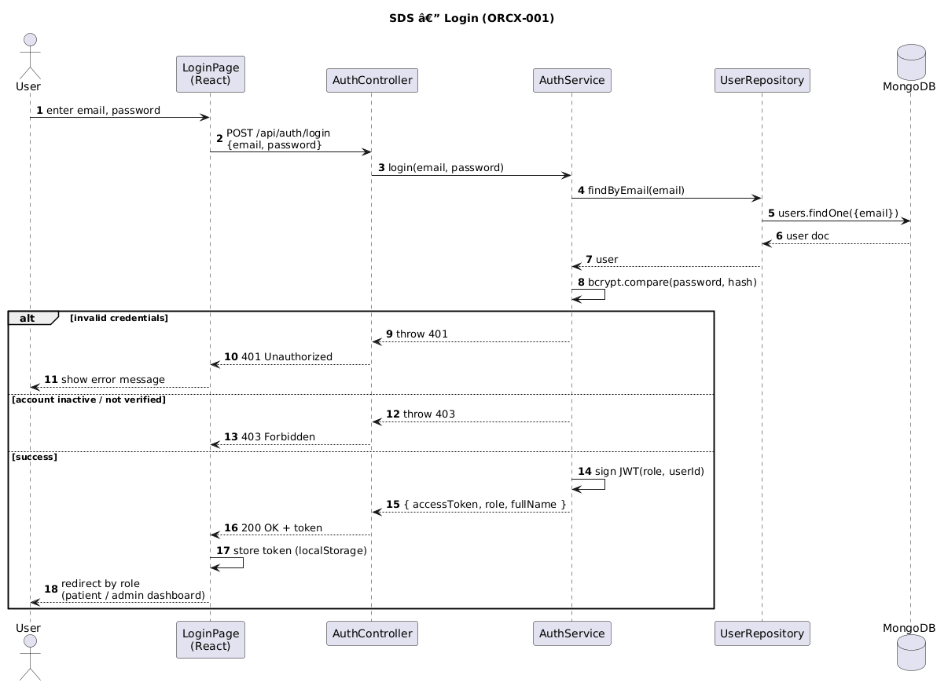
Figure 5 — Sequence: Login
Module | Responsibility
LoginPage | Form UI, store JWT
AuthController | POST /api/auth/login
AuthService | bcrypt + sign JWT
UserRepository | MongoDB users

Feature: Register + Verify Email (ORCX-003, ORCX-005)
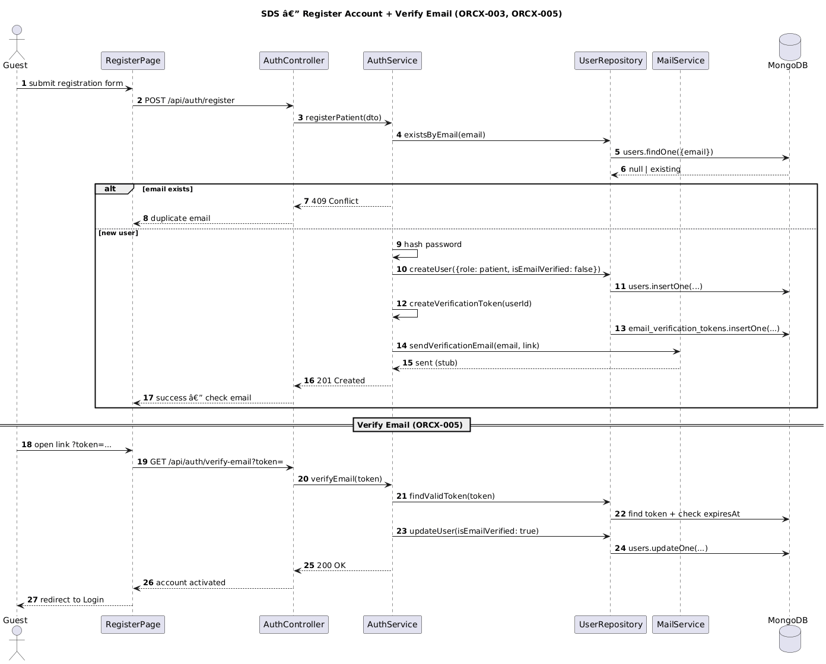
Figure 6 — Sequence: Register & Verify Email

Feature: Create Doctor (ORCX-027)
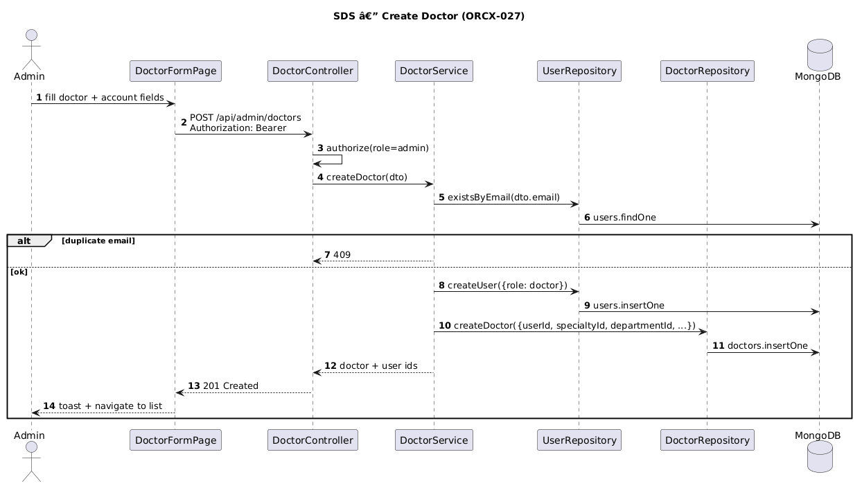
Figure 7 — Sequence: Create Doctor

Feature: Search Doctors (ORCX-038)
SearchDoctorsPage → GET /api/public/doctors?name&specialtyId&departmentId&page → DoctorService.search → MongoDB find on doctors (isActive=true) with filters.

